Modul 7

Nama : Wildhan Haidar Nusa

NIM : 2105101112

Tag Div

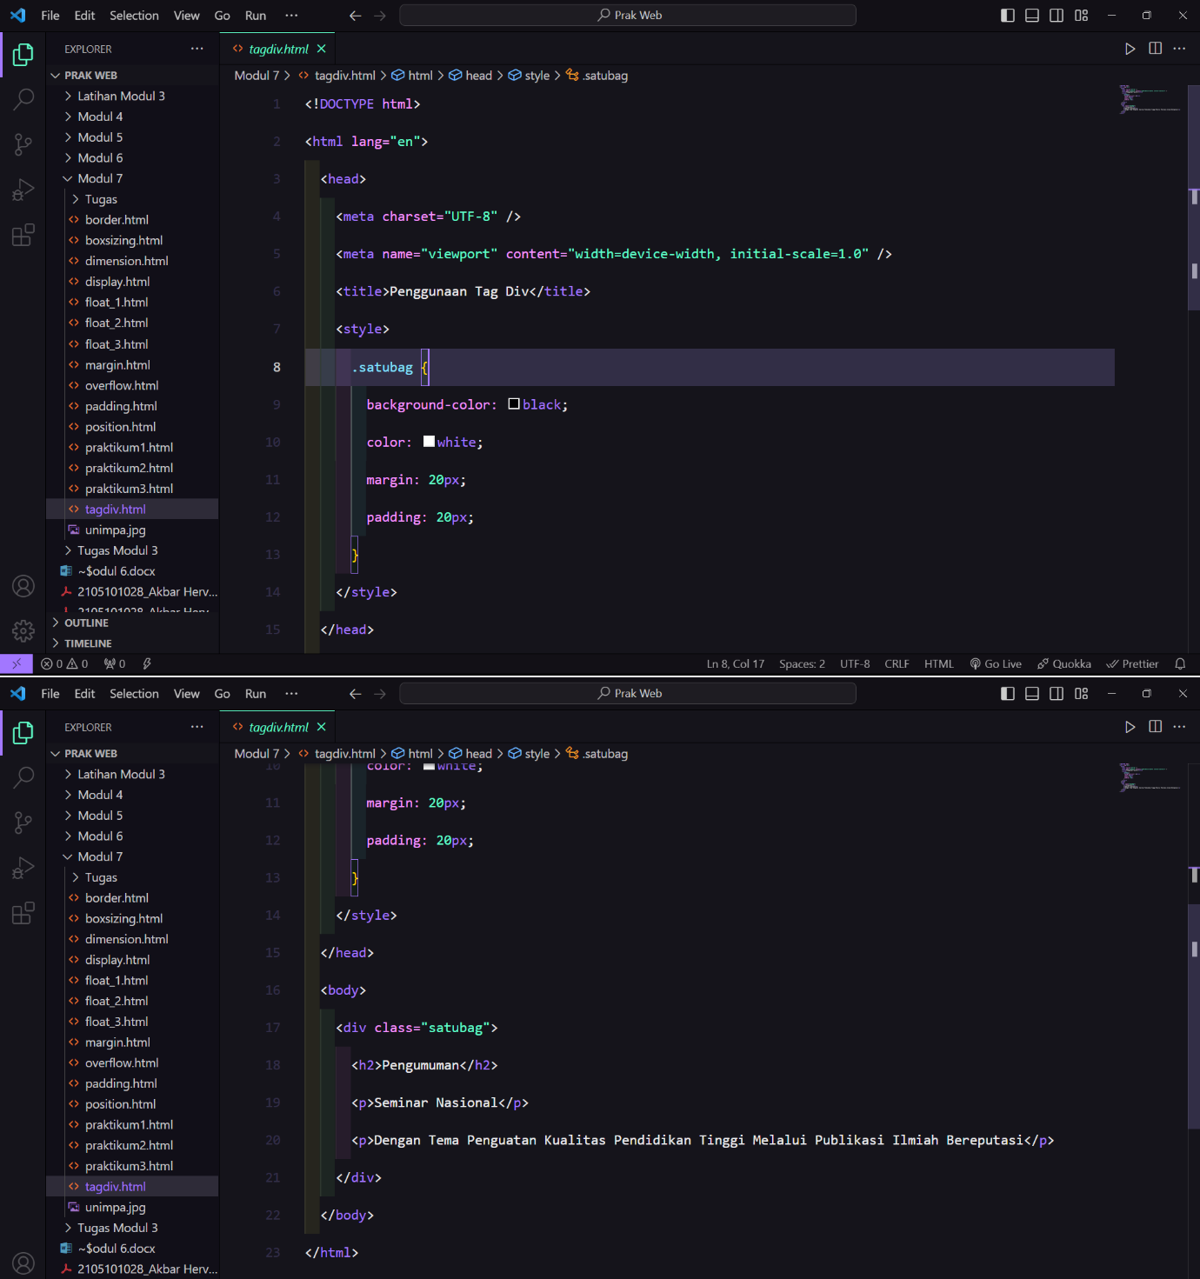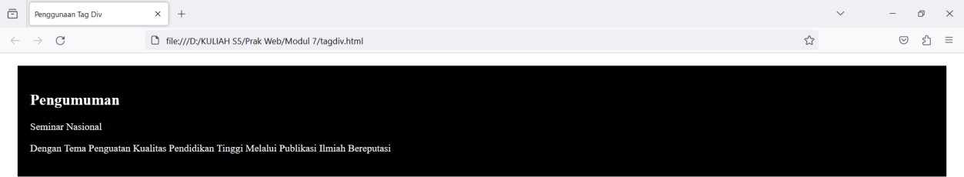

Praktikum 1

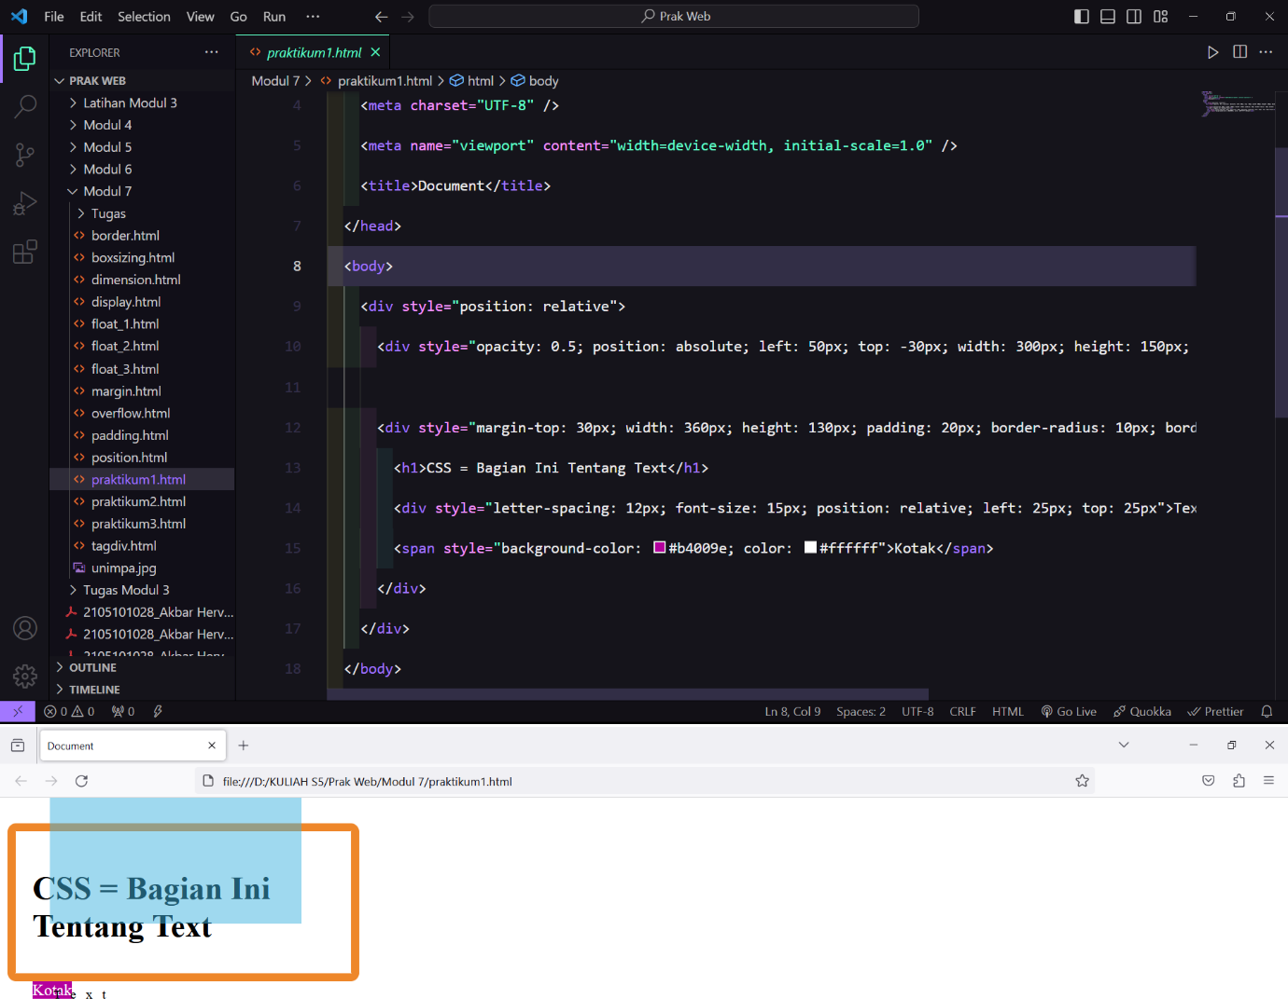

Praktikum 2

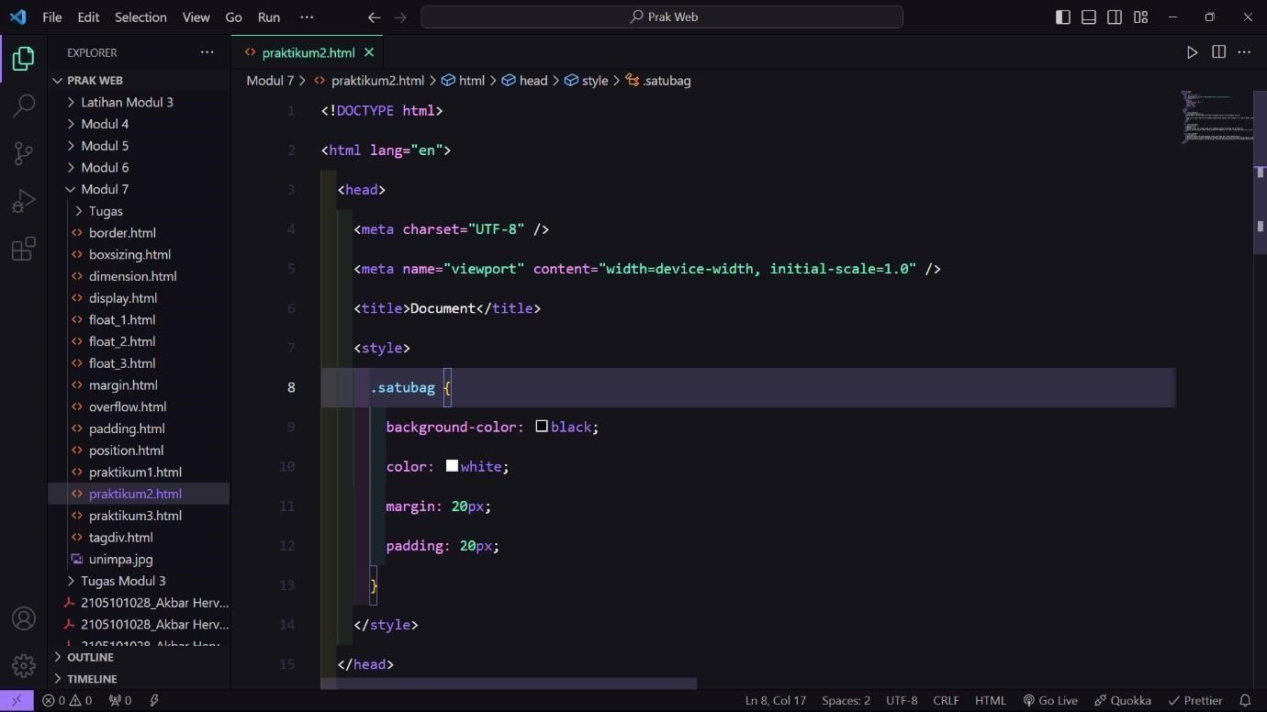

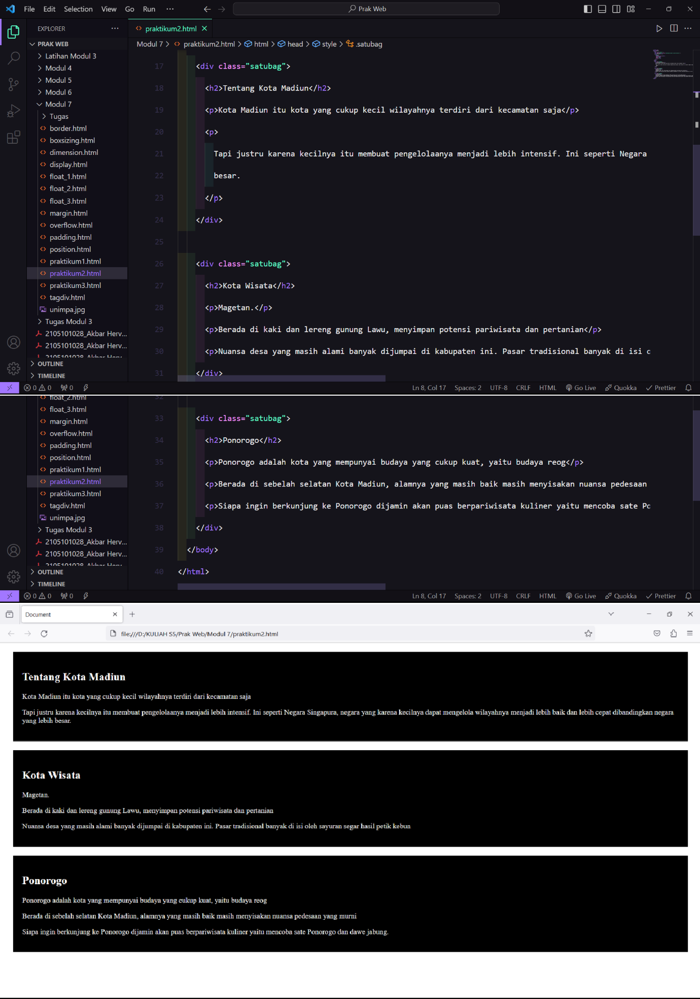

Praktikum 3

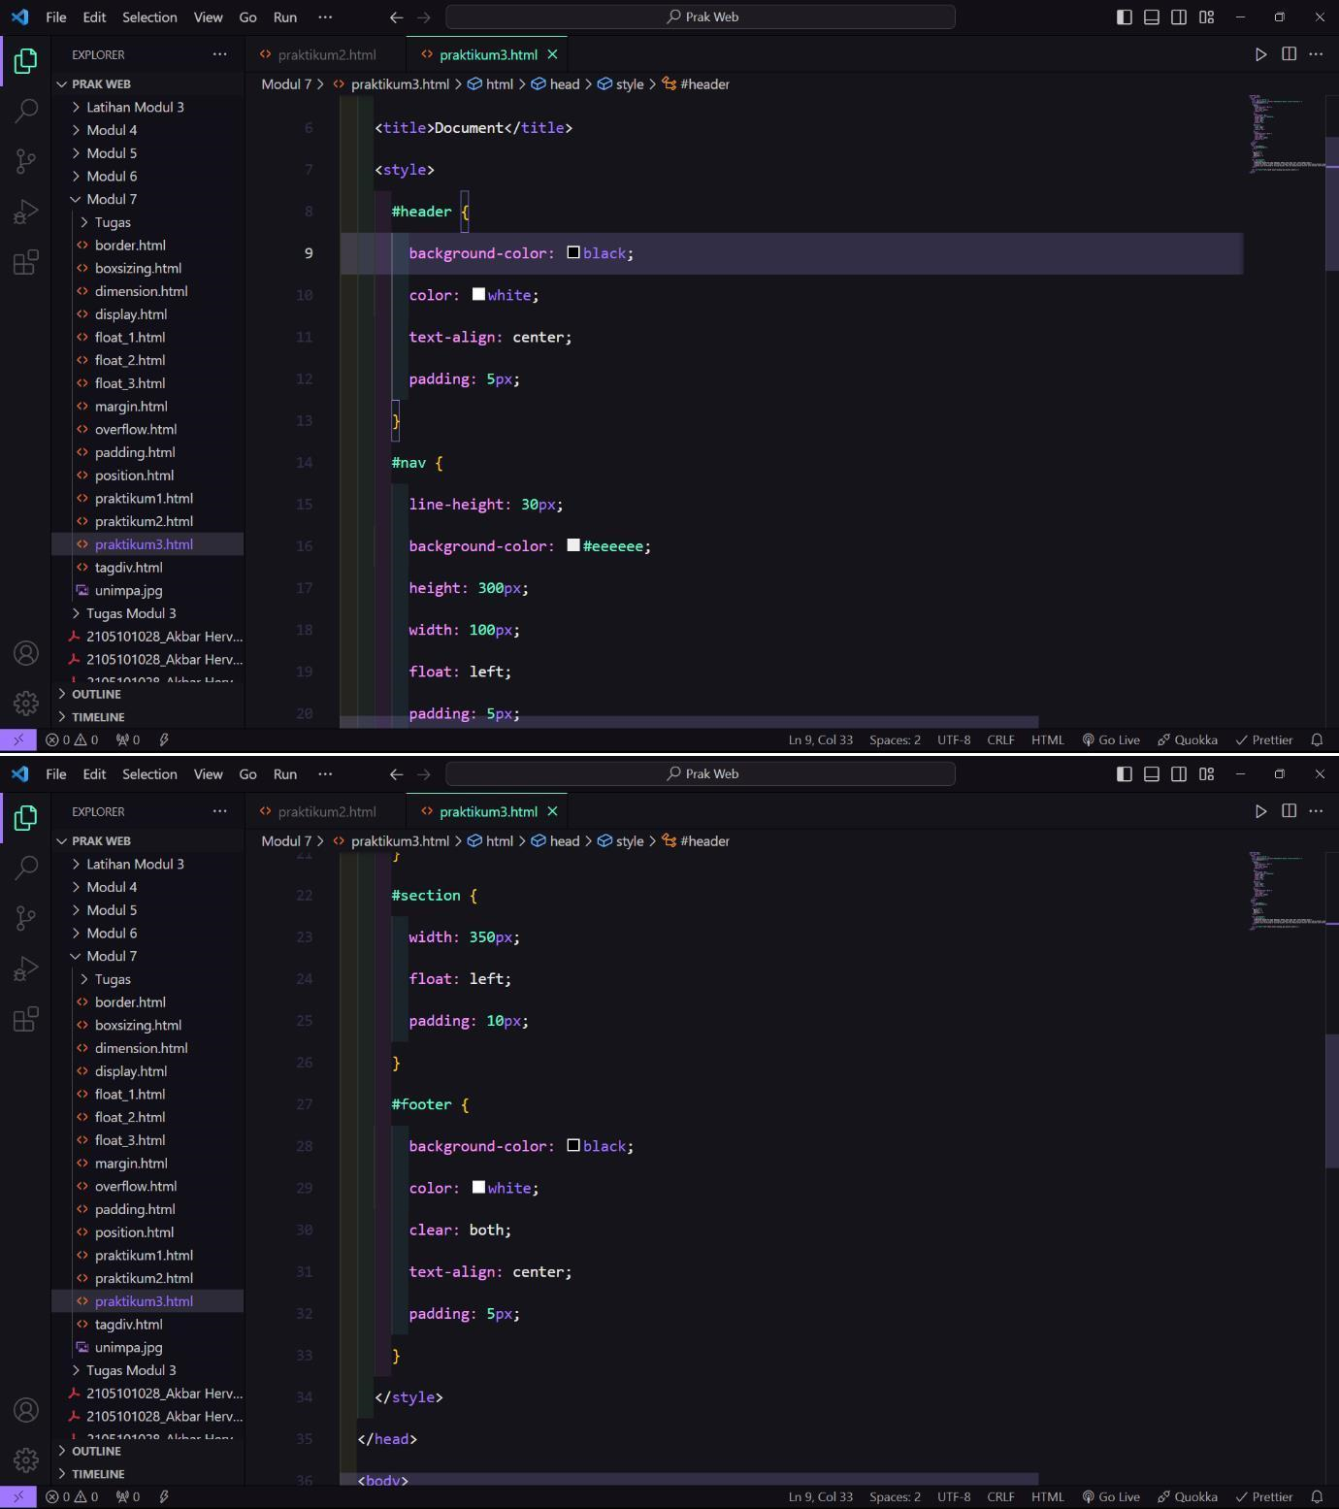

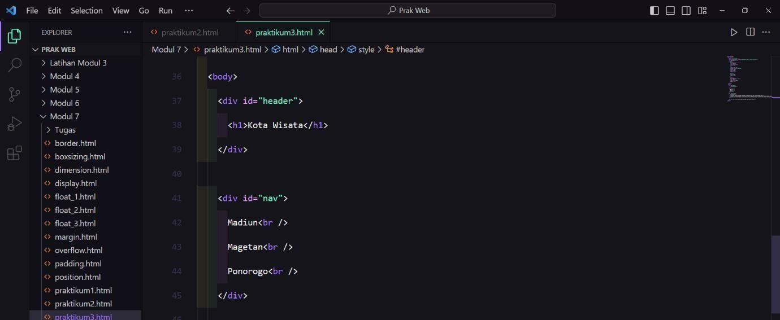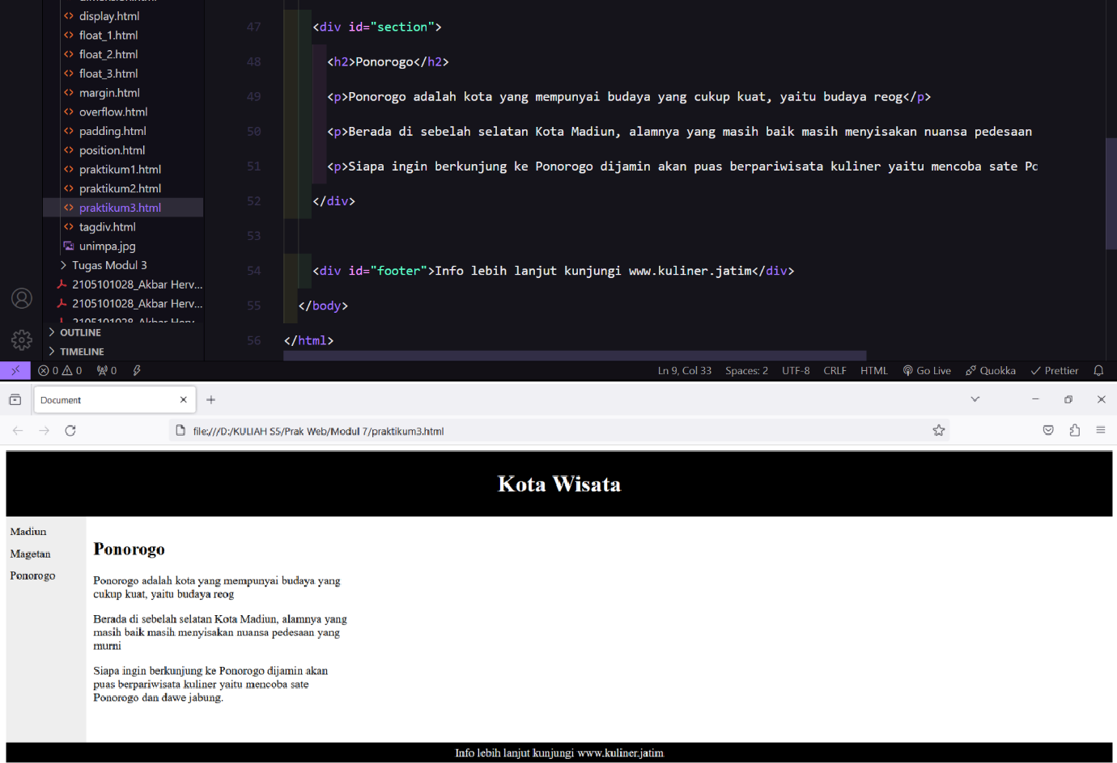

Display

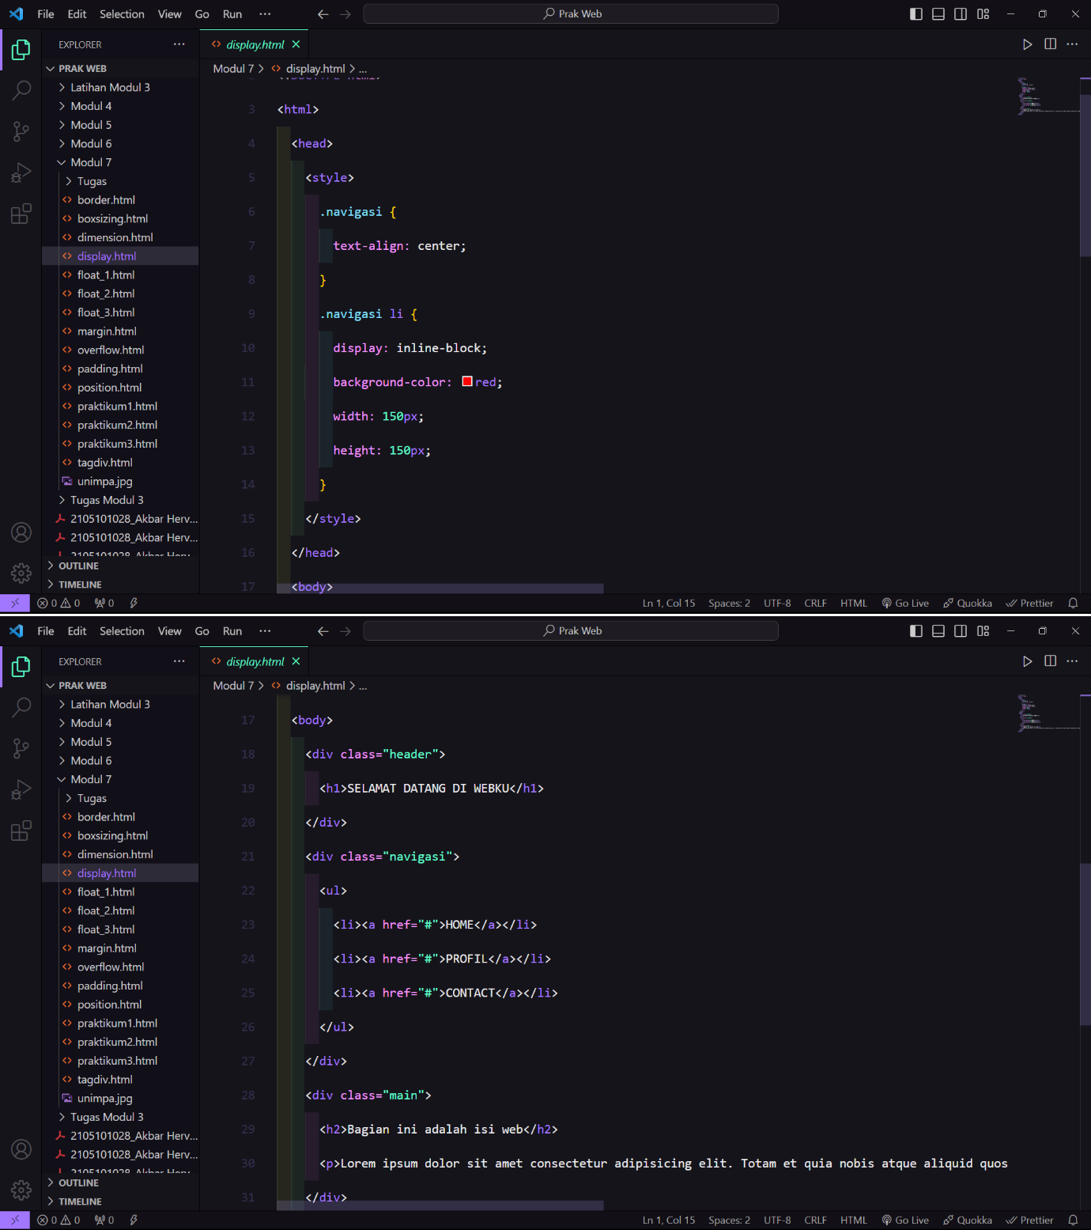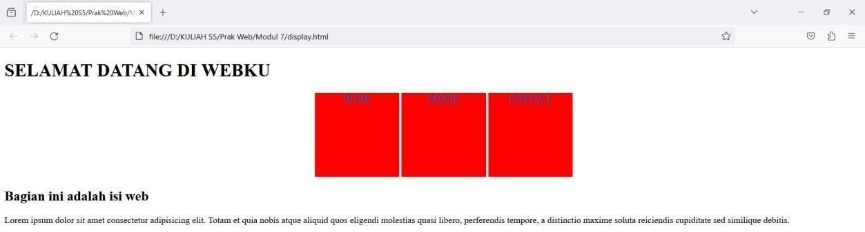

Dimension

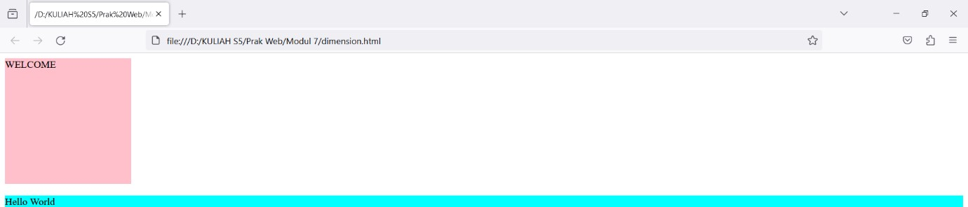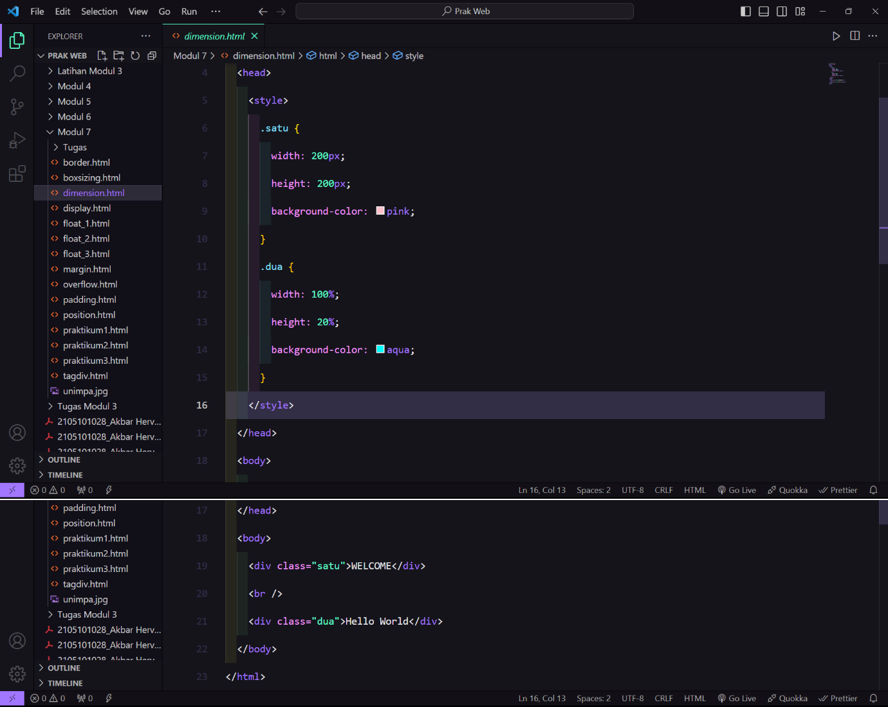

Overflow

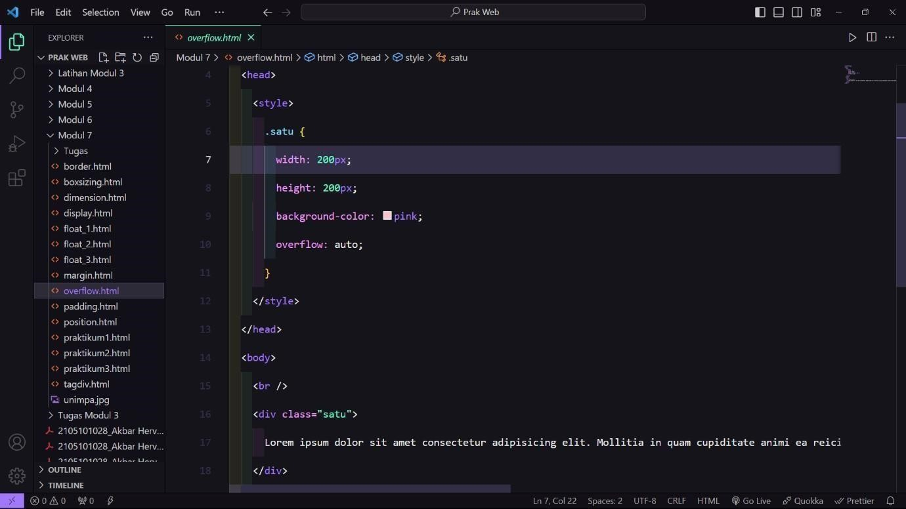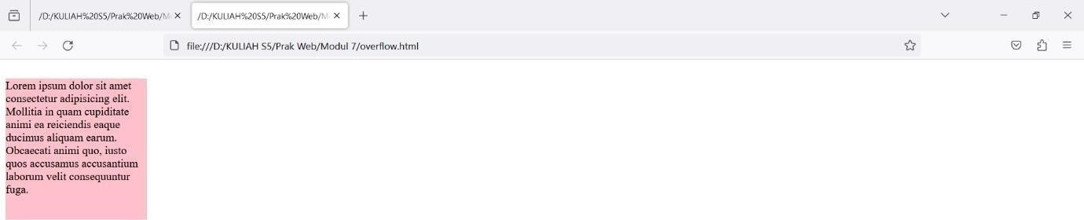

Margin

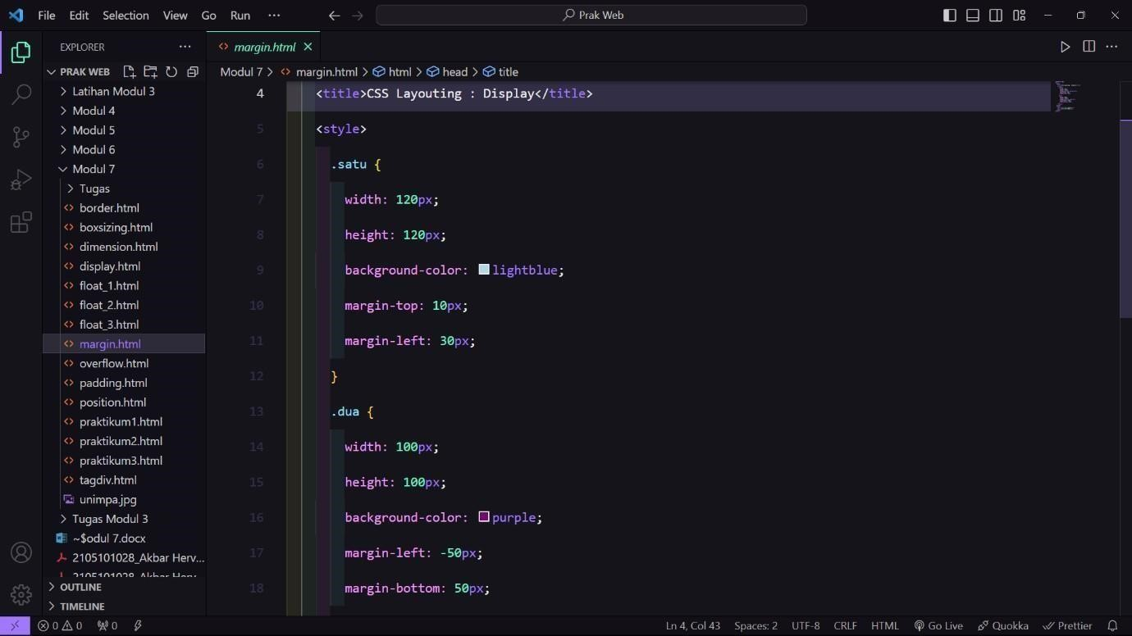

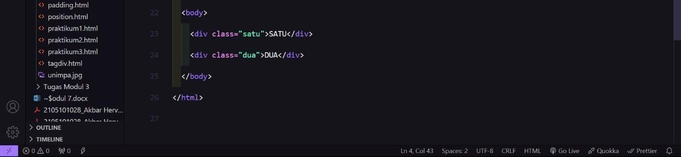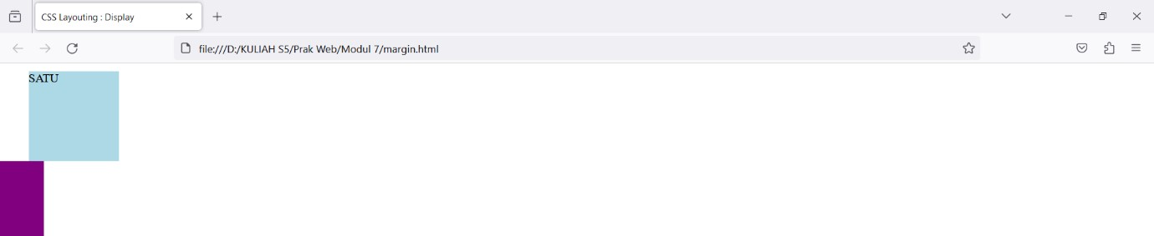

Border

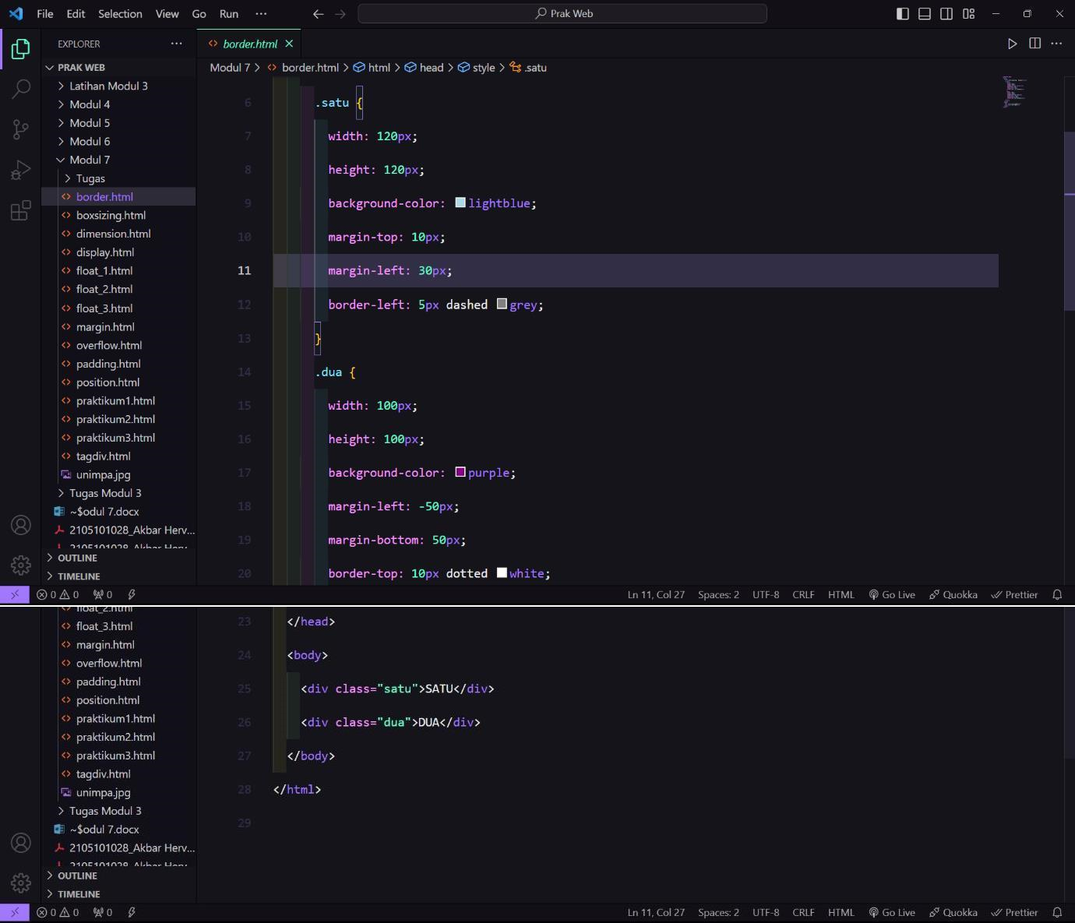

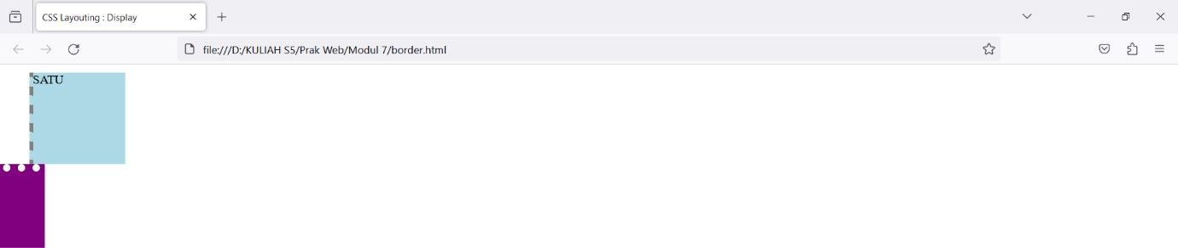

Padding

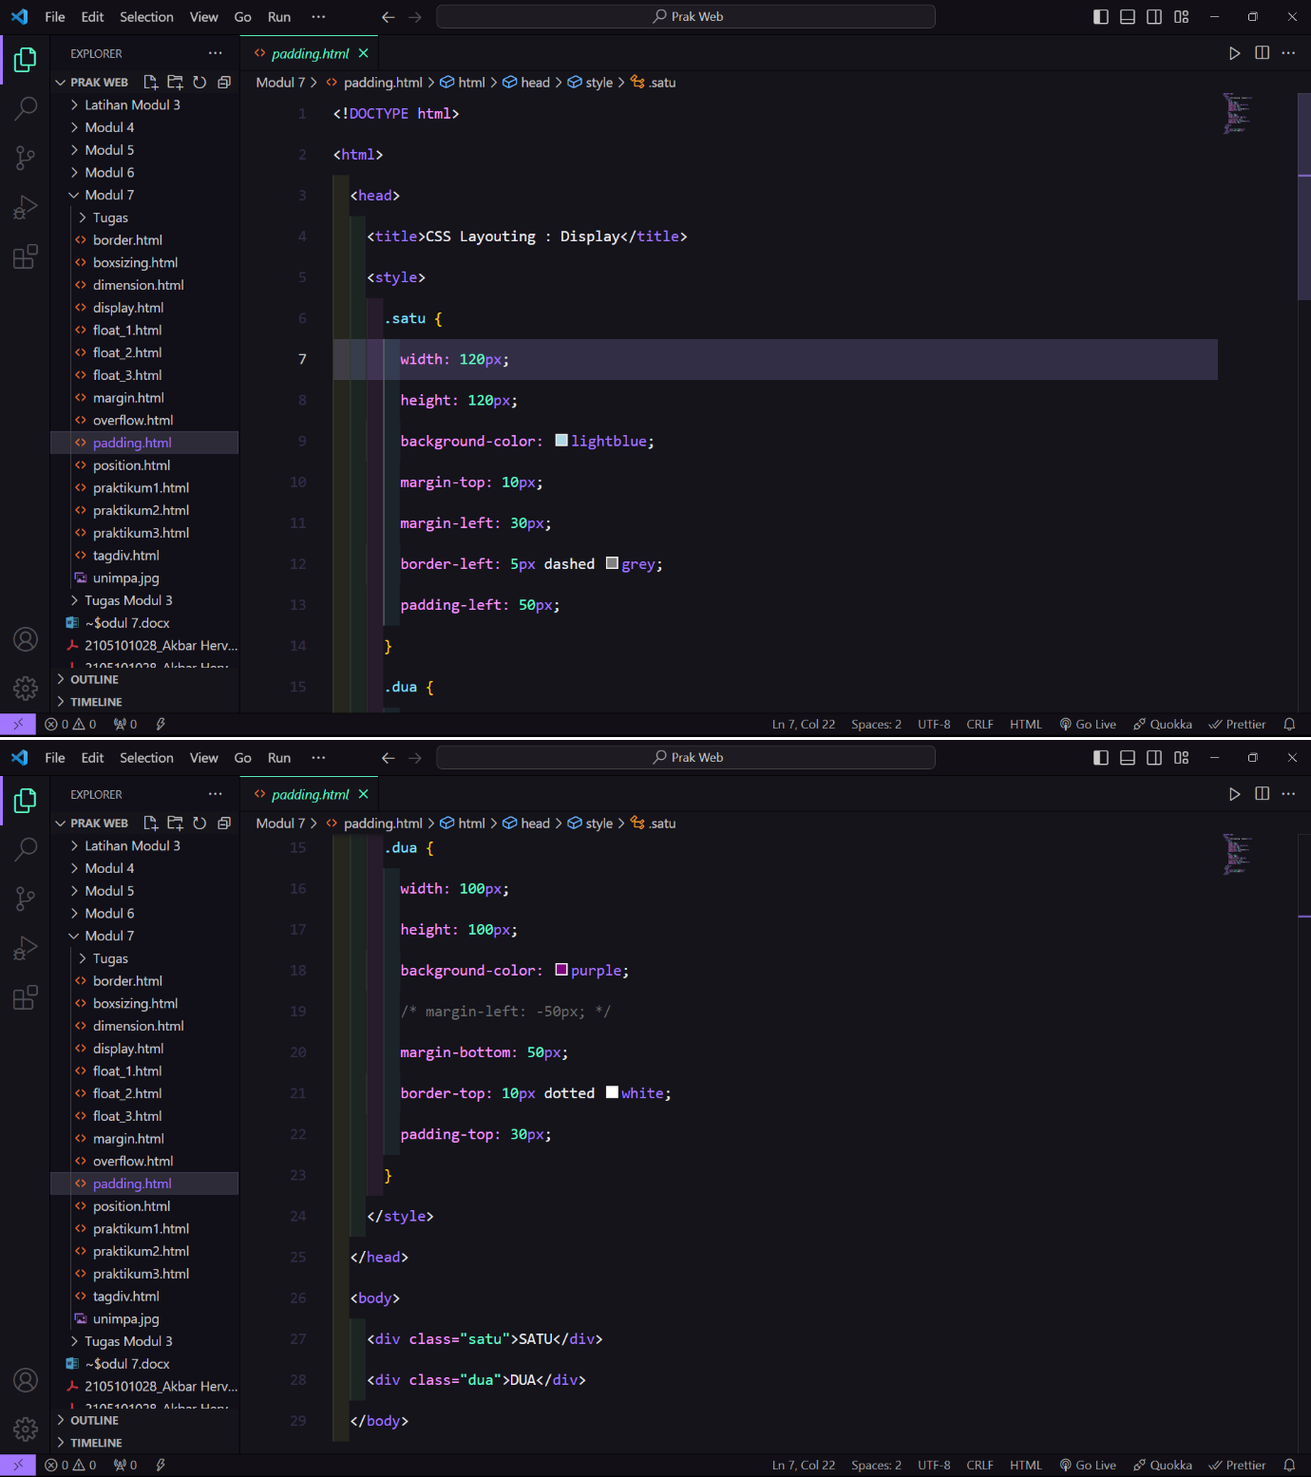

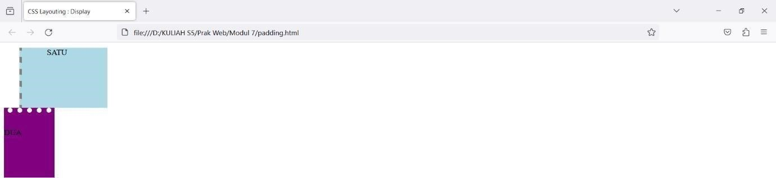

Box Sizing

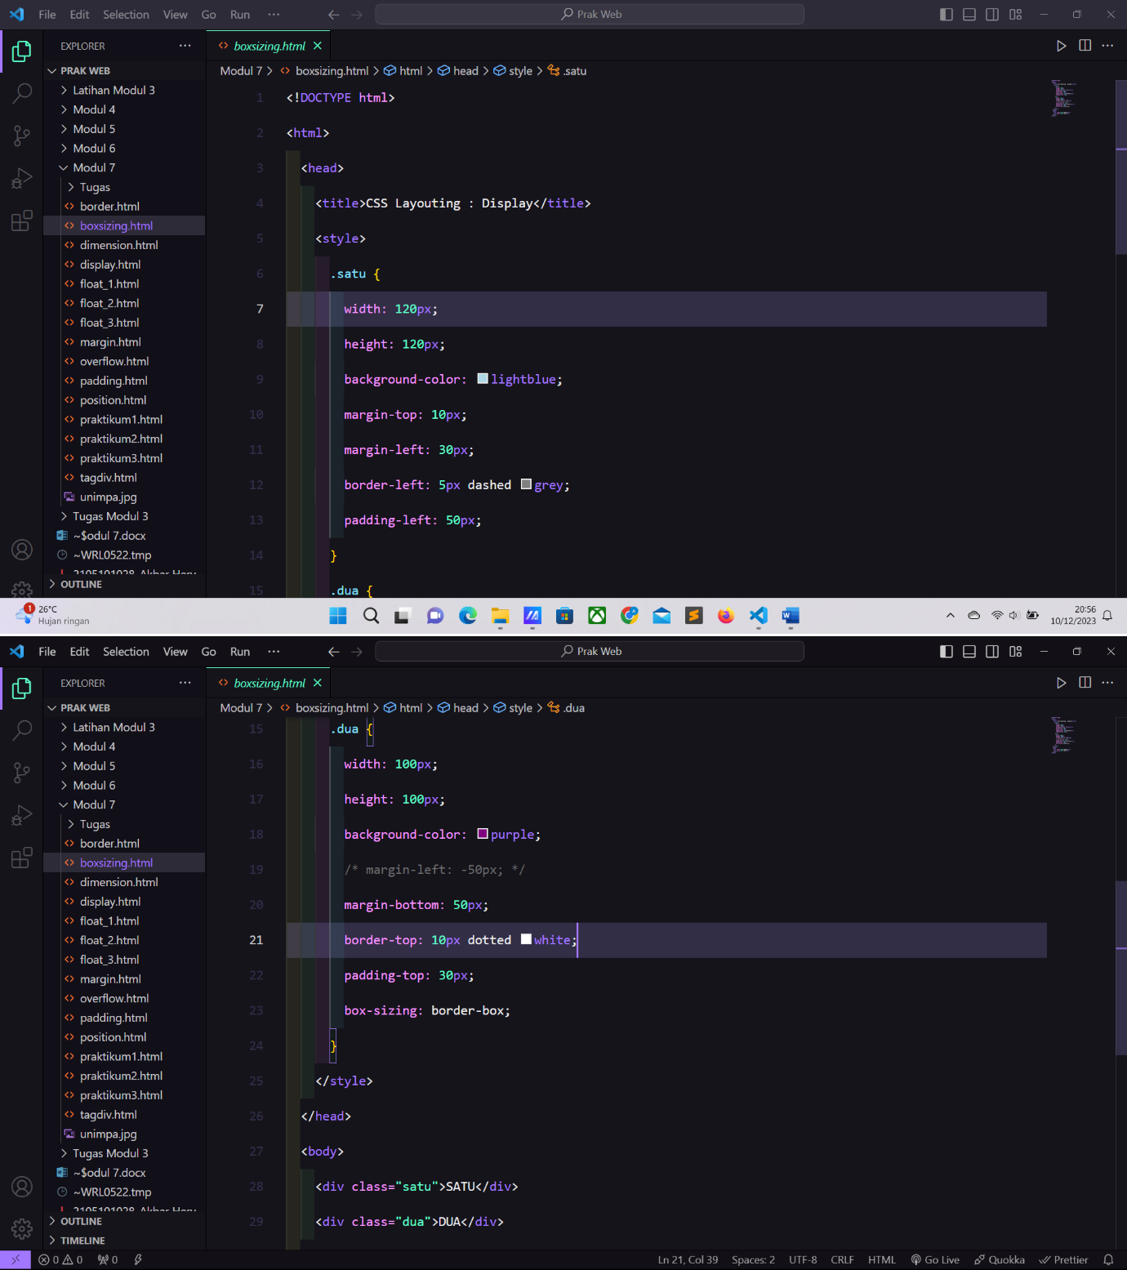

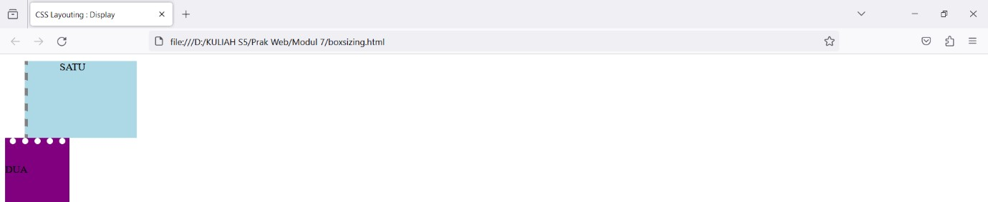

Float

Text Wrapping

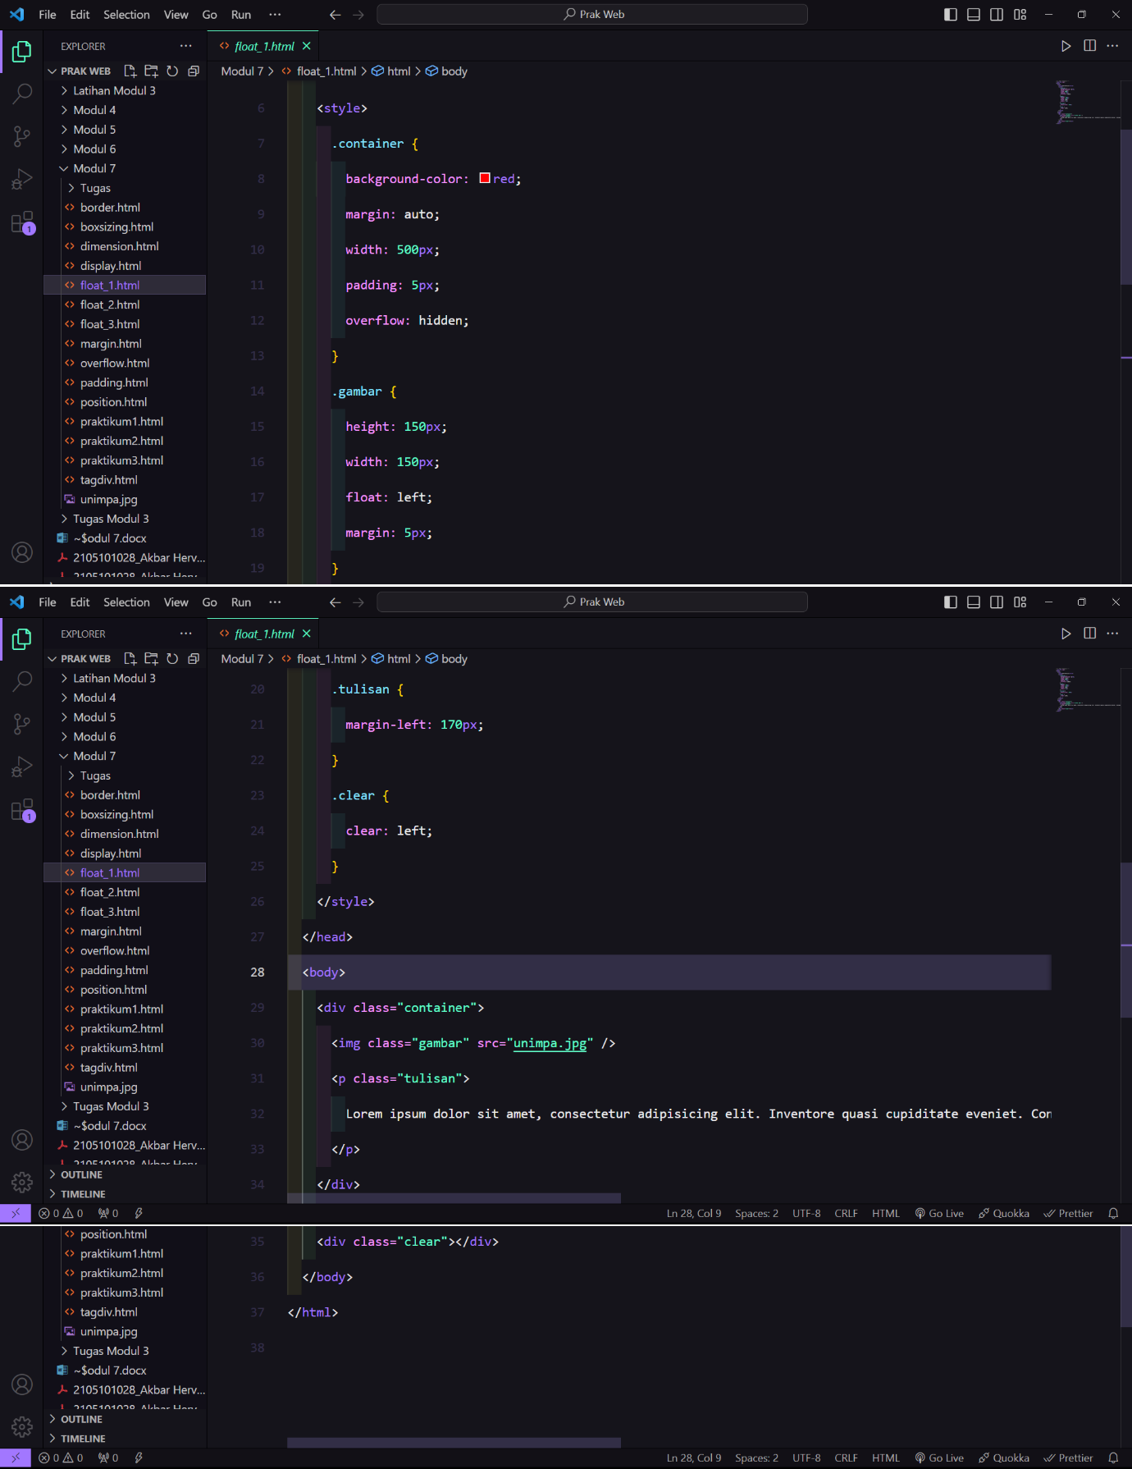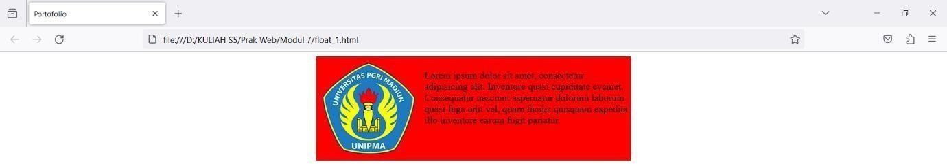

Float

Image Gallery

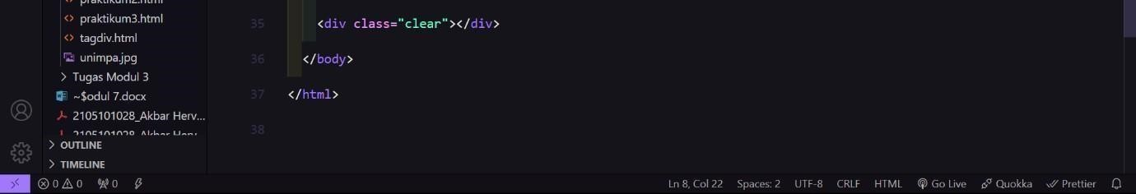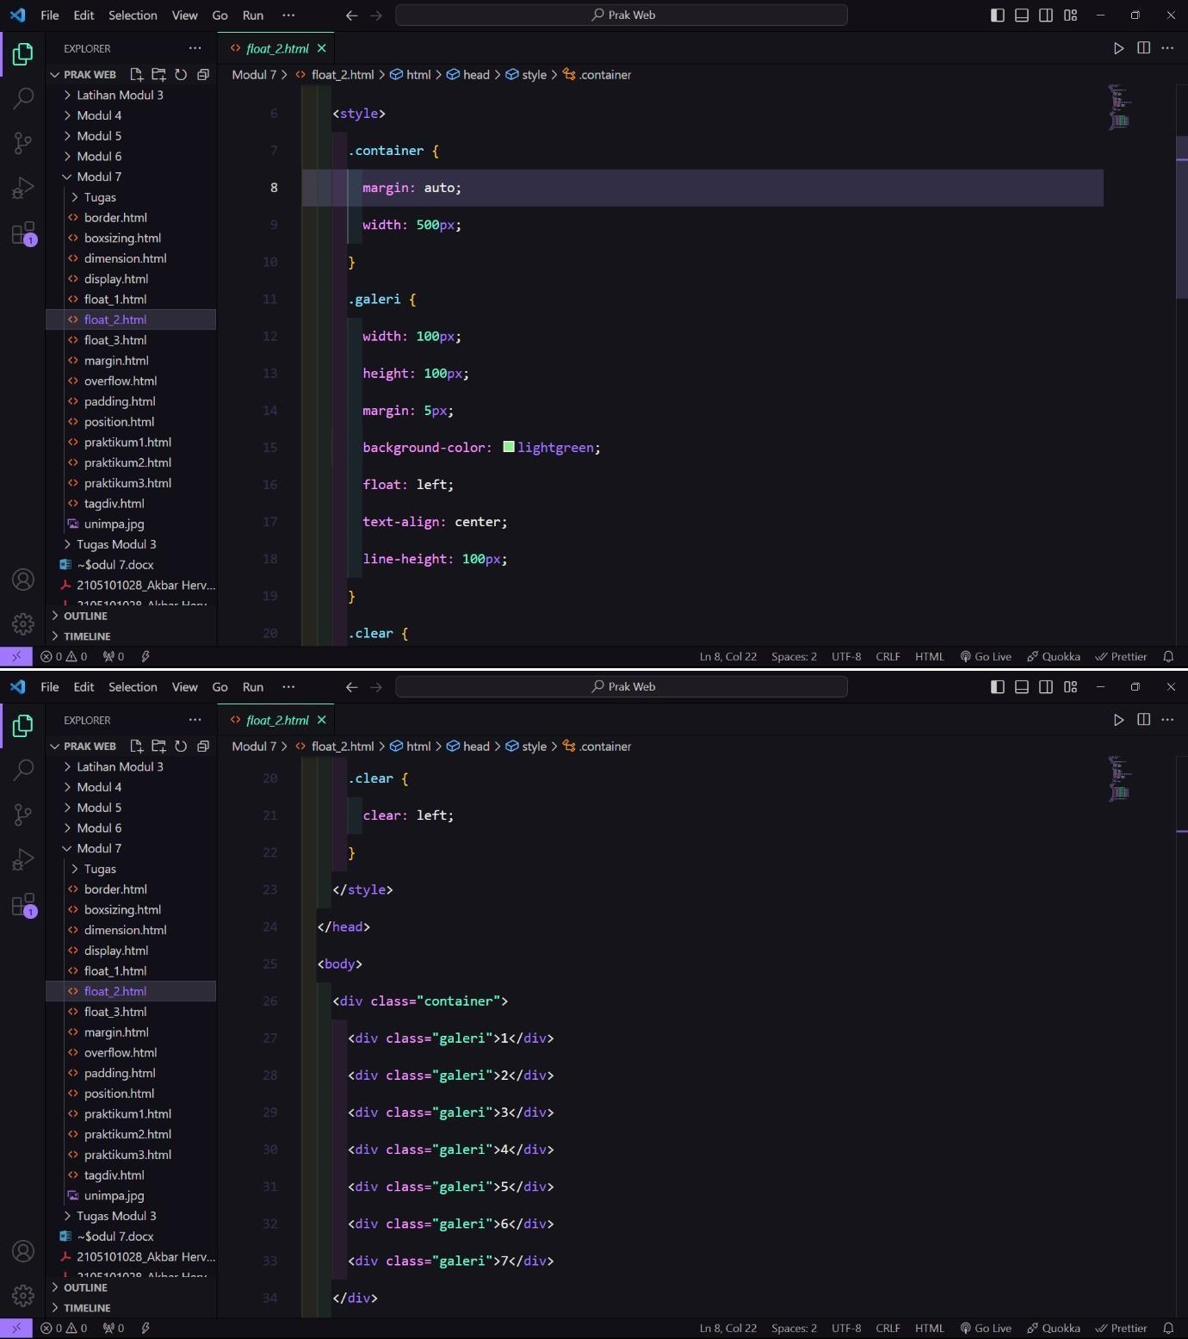

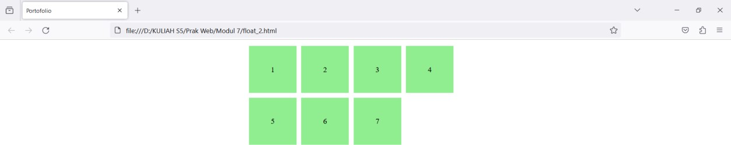

Float

Multi-Colum Layout

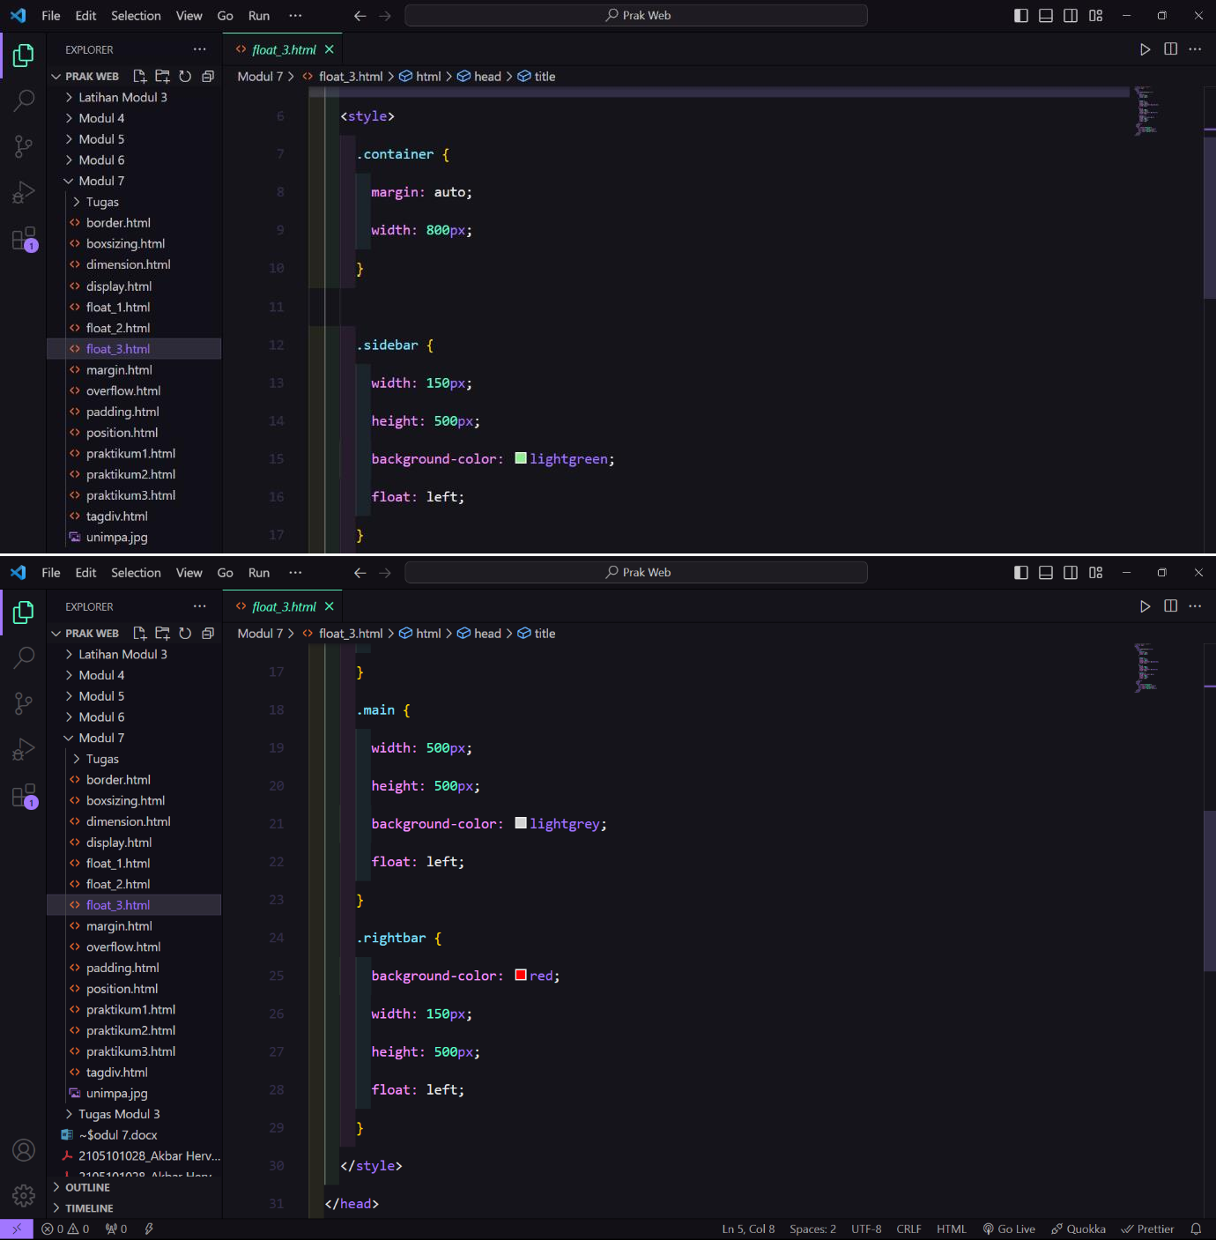

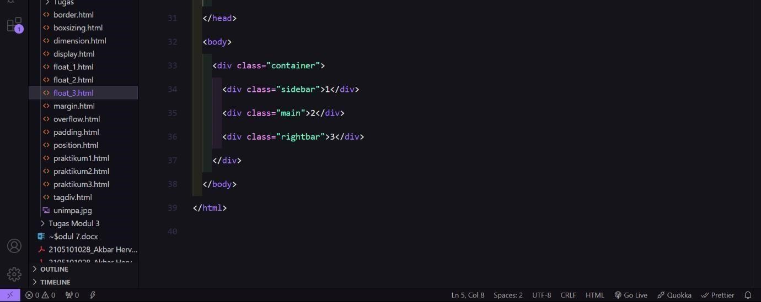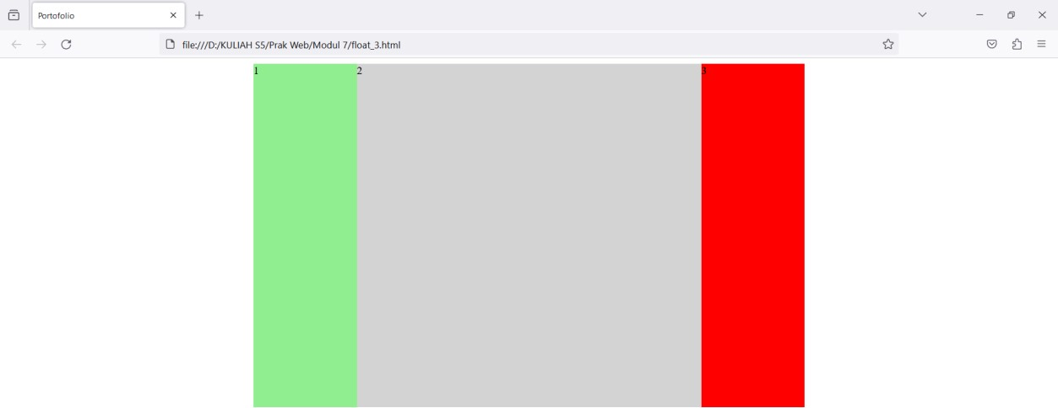

Position

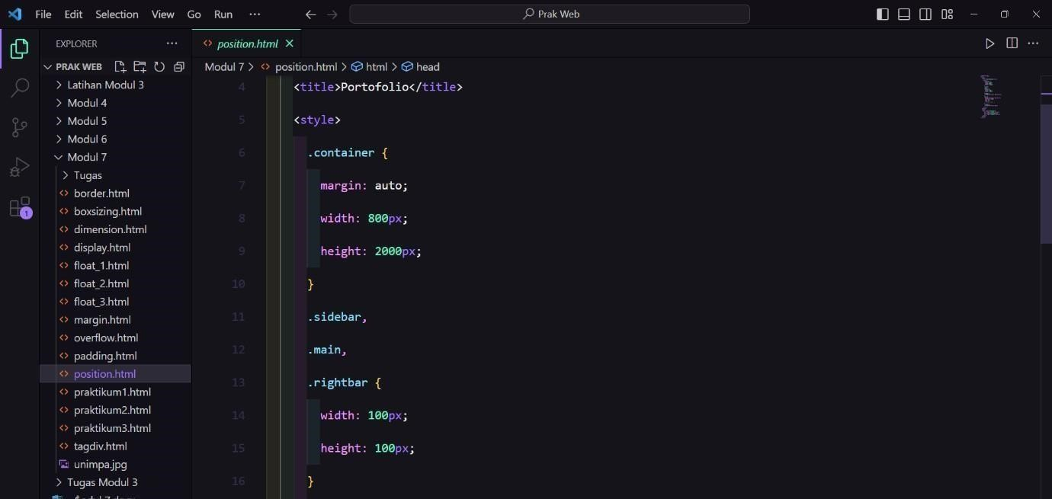

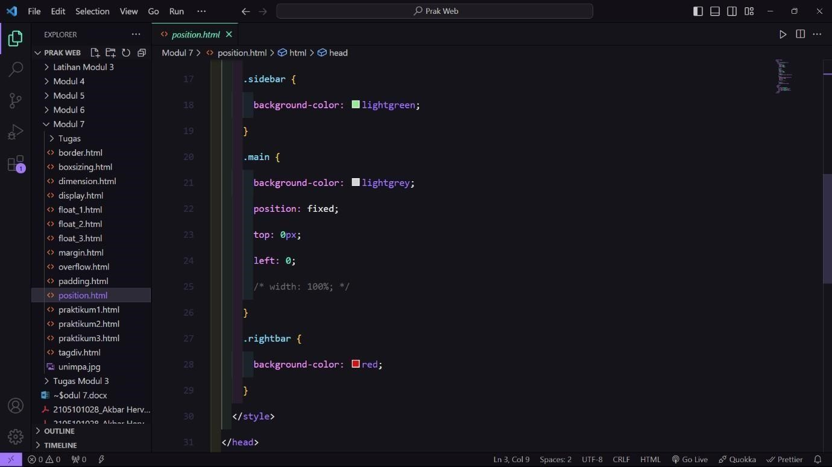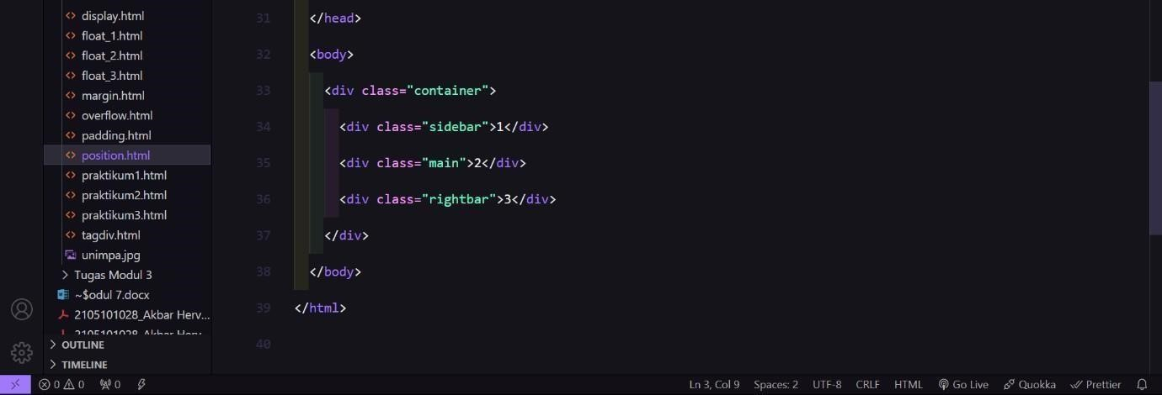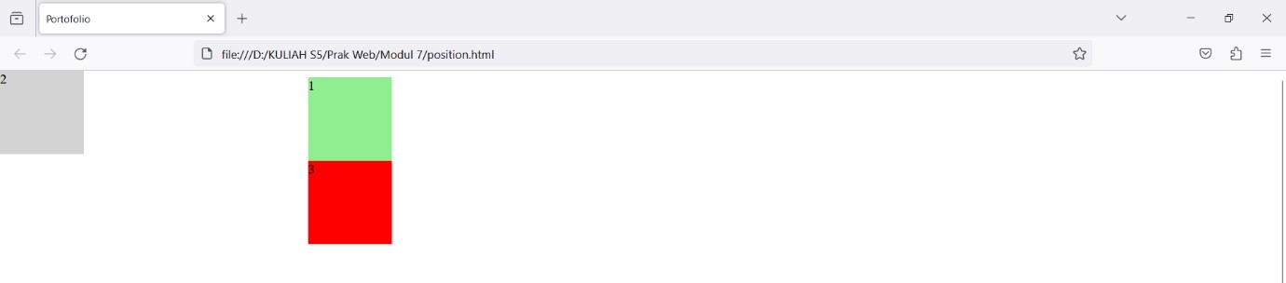

Tugas Praktikum

|  |
| --- |
| <!DOCTYPE html>  <html lang="en">  <head>  <meta charset="UTF-8" /> |

|  |
| --- |
|  |
| <meta name="viewport" content="width=device-width, initial- scale=1.0" />  <title>Portofolio</title>  <link rel="stylesheet" href="style.css" />  </head>  <body id="home">  <nav>  <ul>  <a href="" class="merk">Valliant Dheka F</a>  <li><a href="#home">Home</a></li>  <!-- <li><a href="#home">About Me</a></li> -->  <li><a href="#profile">Profile</a></li>  <li><a href="#profile">Contact</a></li> </ul>  </nav>  <div class="container">  <div id="about">  <img src="img/logo2.jpg" alt="" width="200px" />  <br></br><br>  <h1>Valliant Dheka F</h1>  <p class="univ">Mahasiswa Universitas PGRI Madiun</p>  <p>Teknik Informatika</p>  <div class="clear"></div> </div> |
|  |
| <div id="profile">  <div class="school"><a href="#sd">SD</a></div>  <div class="school"><a href="#smp">SMP</a></div>  <div class="school"><a href="#sma">SMA</a></div>  </div>  <div id="sd">  <h2>SD</h2>  <p>Lorem ipsum dolor sit amet consectetur adipisicing  elit. Exercitationem, animi.</p>  </div>  <div id="smp">  <h2>SMP</h2>  <p>Lorem ipsum dolor sit amet consectetur adipisicing  elit. Nesciunt suscipit ratione cum minus numquam magni saepe eligendi dolores delectus cumque.</p> </div> |

|  |
| --- |
| <div id="sma">  <h2>SMA</h2>  <p>Lorem ipsum dolor sit, amet consectetur adipisicing  elit. Sed repellendus libero aut! A minima, nihil laboriosam corporis eos dolore eligendi numquam debitis quam vero alias.  Tenetur vel expedita eligendi inventore.</p> </div>  </div>  </body |

CSS

|  |
| --- |
| /* html { padding: 0; margin: 0;  } */ html { background-color: red;  }    nav { width: 100%; background-color: red; position: fixed; top: 0; left: 0; text-align: end; font-size: 1.1rem; z-index: 99999999;  } nav ul { transform: translateX(-10em);  } nav ul li { margin-right: 20px; display: inline-block;  }    nav ul li a { |
| text-decoration: none; color: white; padding: 5px;  }    nav ul .merk { text-decoration: none; color: white; margin-right: 49em;  }  .container { width: 80%;  background-color: white; margin: auto;  } |

|  |
| --- |
| #about { text-align: center;  transform: translateY(5em);  }  #about img { float: left; border-radius: 50%; transform: translateX(22em); border: 5px solid red;  }  .clear { clear: left;  }  #about h1, p { |

|  |
| --- |
| transform: translateY(1em);  }  .container #about .univ { transform: translateY(2em);  }  #profile { display: flex; justify-content: space-around; margin-top: 10em;  }  #profile .school { width: 100px; height: 100px; background-color: red; |
| transform: translateY(1em);  }  .container #about .univ { transform: translateY(2em);  }  #profile { display: flex;  justify-content: space-around; margin-top: 10em;  }  #profile .school { width: 100px; height: 100px; background-color: red; |
| text-align: center; line-height: 100px; display: flex; flex-direction: column; align-items: center; justify-content: center; border-radius: 1em;  }  #profile a { text-decoration: none; color: black;  }  #sd,  #smp, |
| display: block; color: black; border: 2em solid #fff; text-align: center; background-color: red; padding: 1.5em;  } |

Hasil

